1. **Profile bug : if I click on profile from studenttest then page not found error**

**if I navigate profile from sidebar then it is opening successfully**

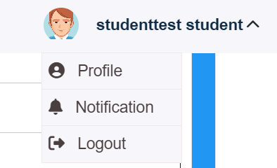

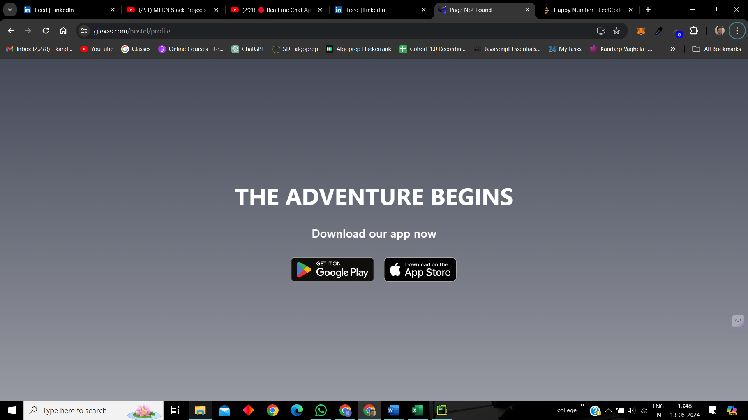



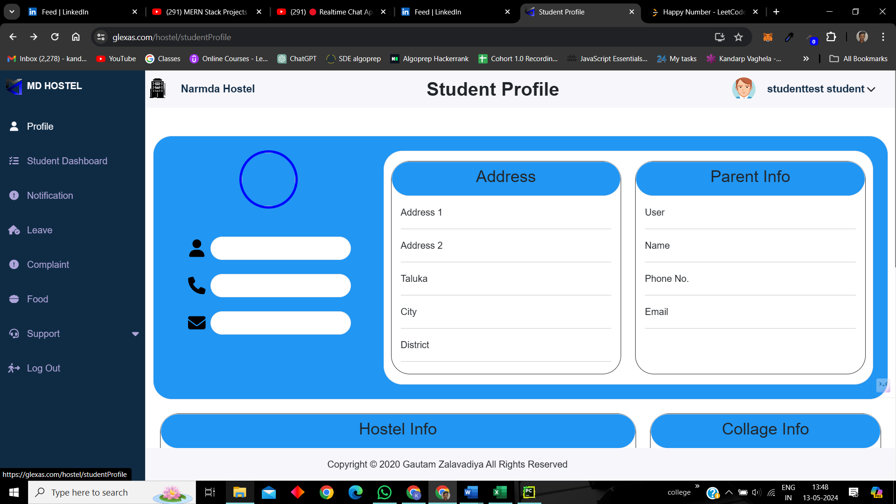

1. **Change credentials**

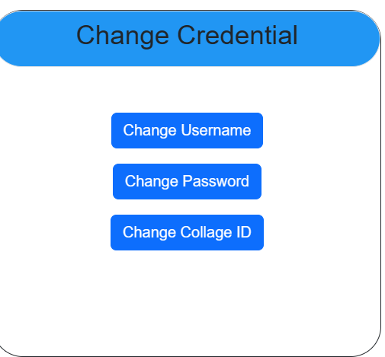



1. **FAQs Video not available**
2. **FAQs photo is of cashback**
3. **Support – save button not working**

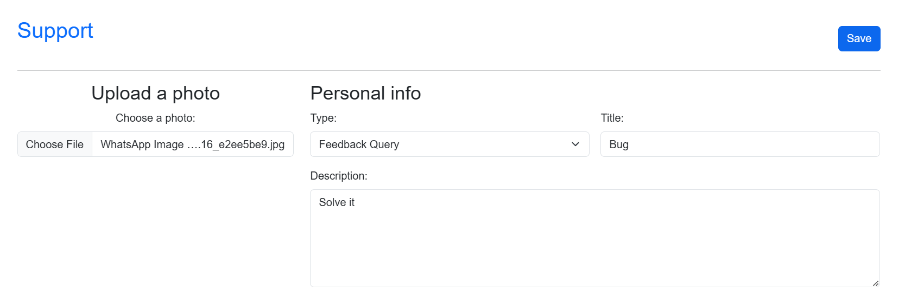

1. **Major bug :** After clicking logout if we click on back or navigate back then it is redirecting to the page from where we logged out. Not asking for the credentials again
2. **Cursor is not changing to pointer in the support**
3. Major bug in FAQ :

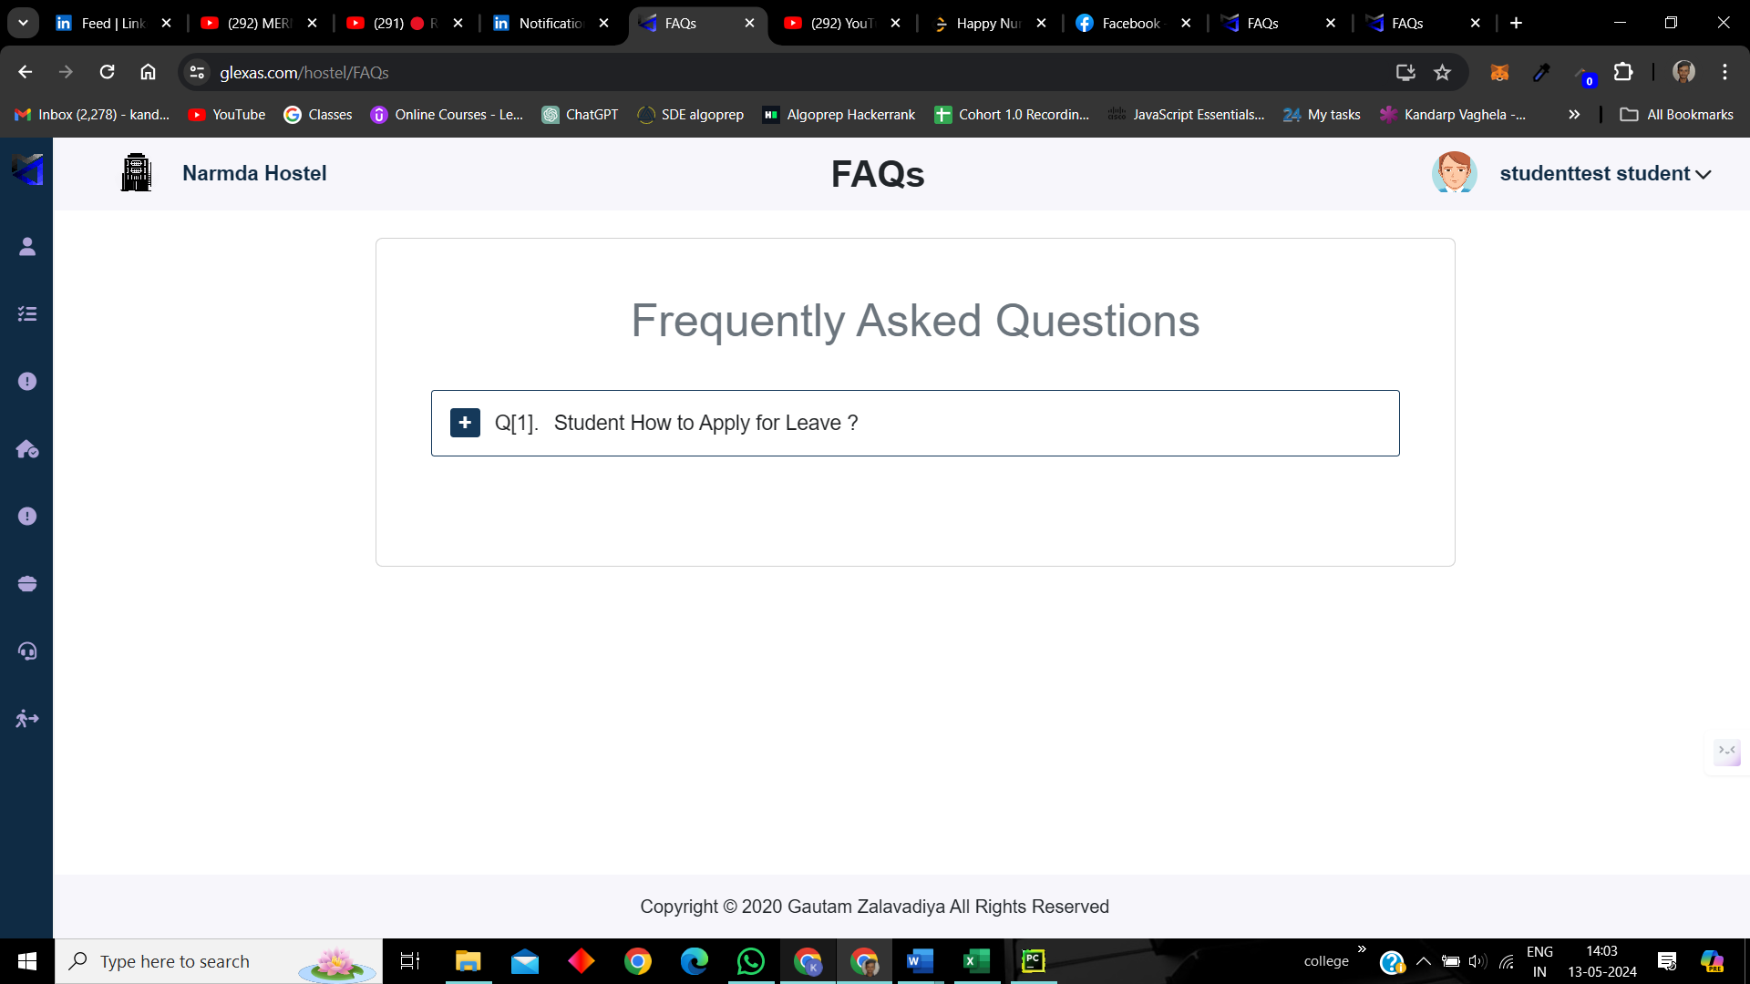

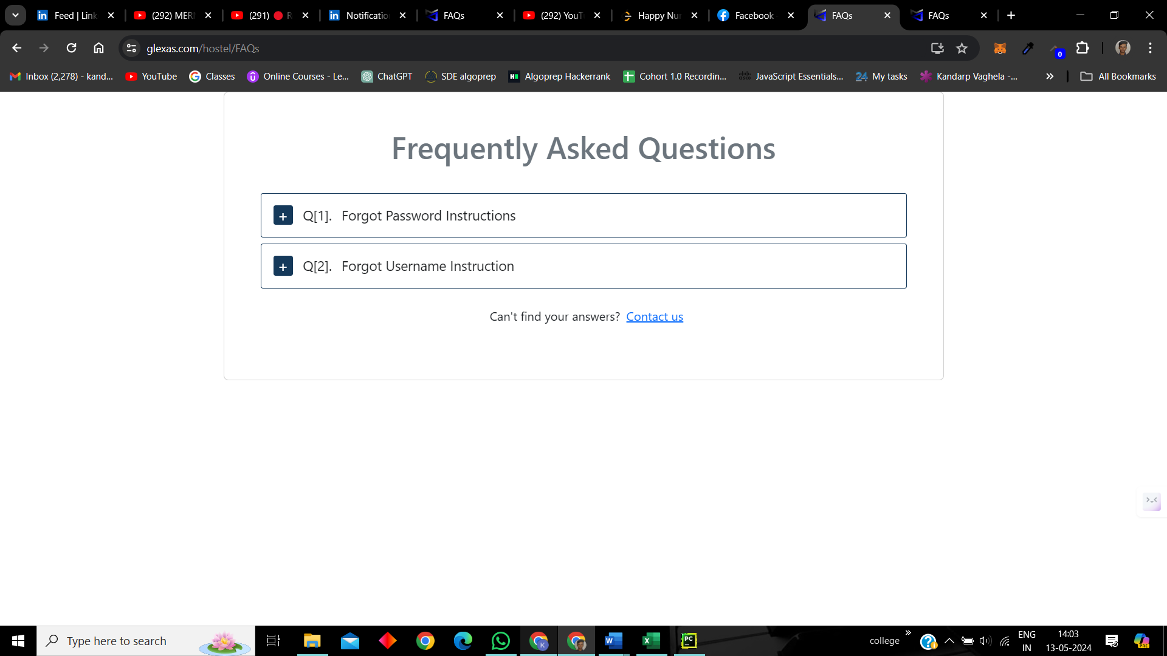

1. **No logic in forgot password** :

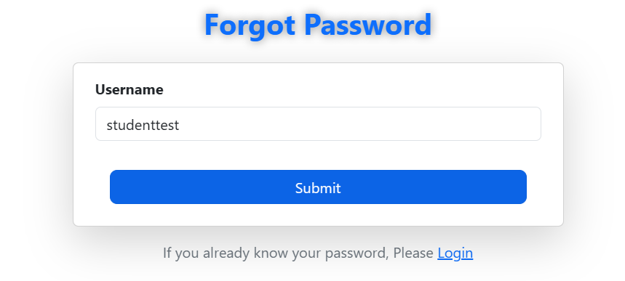

1. **Manager credentials**

new admission is showing but as soon as you click on it is there is a blank page of admission list

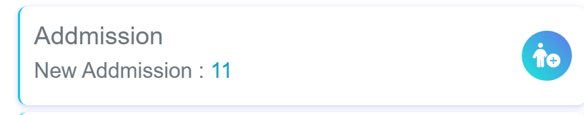

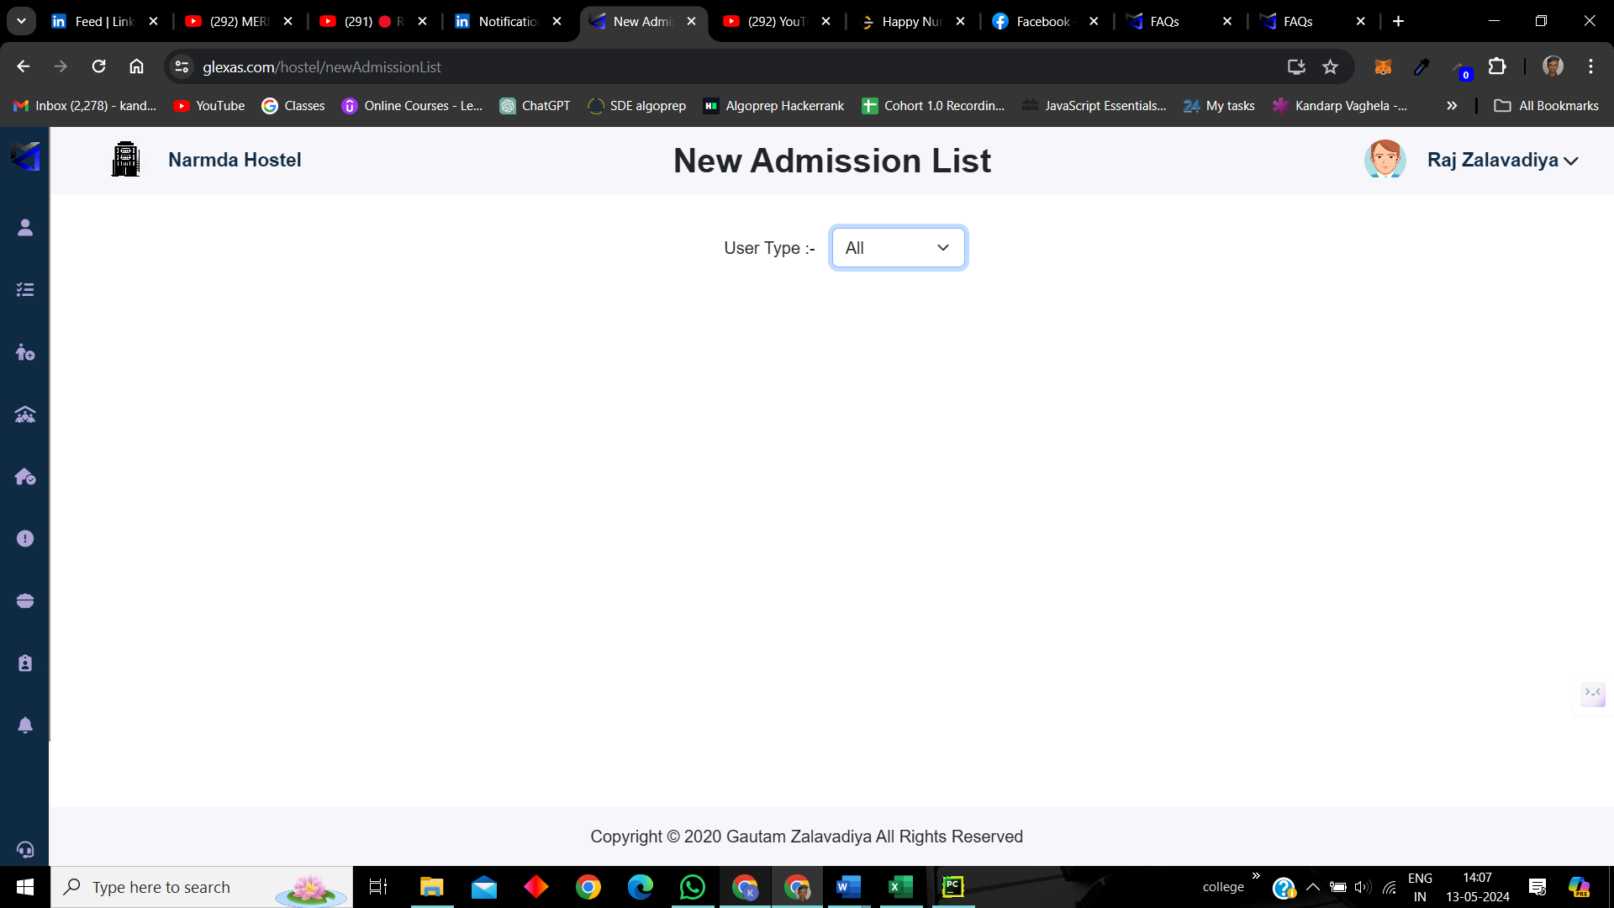

1. **Same for attendance**
2. **Room Transfer :** Nothing is happening on clicking on submit

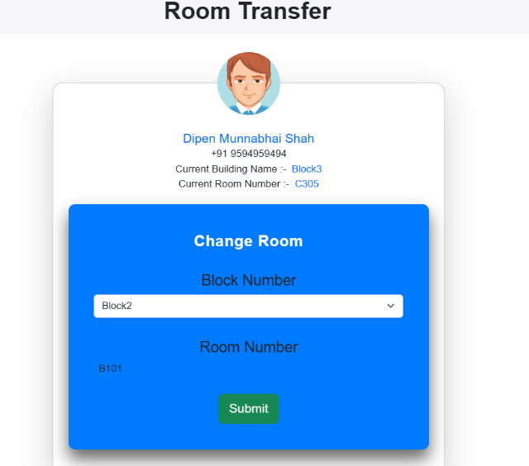

1. **Manager Leave problem :** If a student is applying for leave then after applying the corresponding leave is not visible in the manager’s section.
2. **Update Food :** Showing the message that food is updated successfully but it is not reflecting anywhere in the website